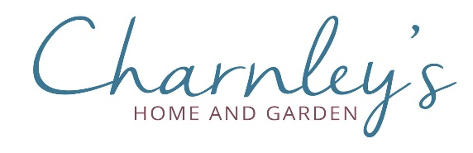
How to book and Deposits
All bookings require a £5 per person, non-refundable deposit. Please complete this form and forward to thebakehouse@charnleys.co.uk . No booking will be confirmed without the appropriate deposit.

Tel: 01229 464225 Email: thebakehouse@charnleys.co.uk Like us on

Date of party: No in party:
Name of Booking:
Contact Name
Address
Postcode:
Telephone: Mob:
Email:

Deposit
Date paid: | Type of payment: Amount: £ | Receipt Number:

Additional Guests
Due to the limited numbers on each day, it may not be possible to increase the size of your party once your deposit has been received. However, will do their best to accommodate your requirements should this need arise.

Special Needs & Dietary Requirements
Our function room is fully accessible for wheelchair users. Please advise us if you have any special dietary requirements before submitting the pre-order, so we may discuss this with our chef.

Pre-Order Form
This form must be returned to us 7 days prior to your event and a £5 Deposit Per Person which will allow our chefs time to order and secure the products.

Pre-Order sheet

Date of party: No. in party:

Name of Booking:

Contact Name:

Email:

Meal pre-order
Name | Starter (optional) | Meal | Sides (optional)
T&C

Group bookings can be made between 11:45 and 3:30 for lunch and 6:30 – 7:30 for evening meals

